Documentation:
- Create the design diagram of your class diagram.
- Create the design description of the attributes and class extent that were implemented in your project.
For an example of how to update your document, please refer to the hobby store document added to this assignment.
To obtain the 3 points for attempting
- Implement 50% of the required attributes and their corresponding classes
- Implement methods to ensure extent persistency - it does not have to be fully implemented.
- Create at least 10 unit tests in accordance with the requirements.
- No documentation update is required for the attempt.

You can obtain 2 additional points for:
- Implementing all the attributes in all the classes in your project (1 point).
- Implementing all the unit tests for all the classes relating to attributes and class extent (1 point).

Class Diagram:
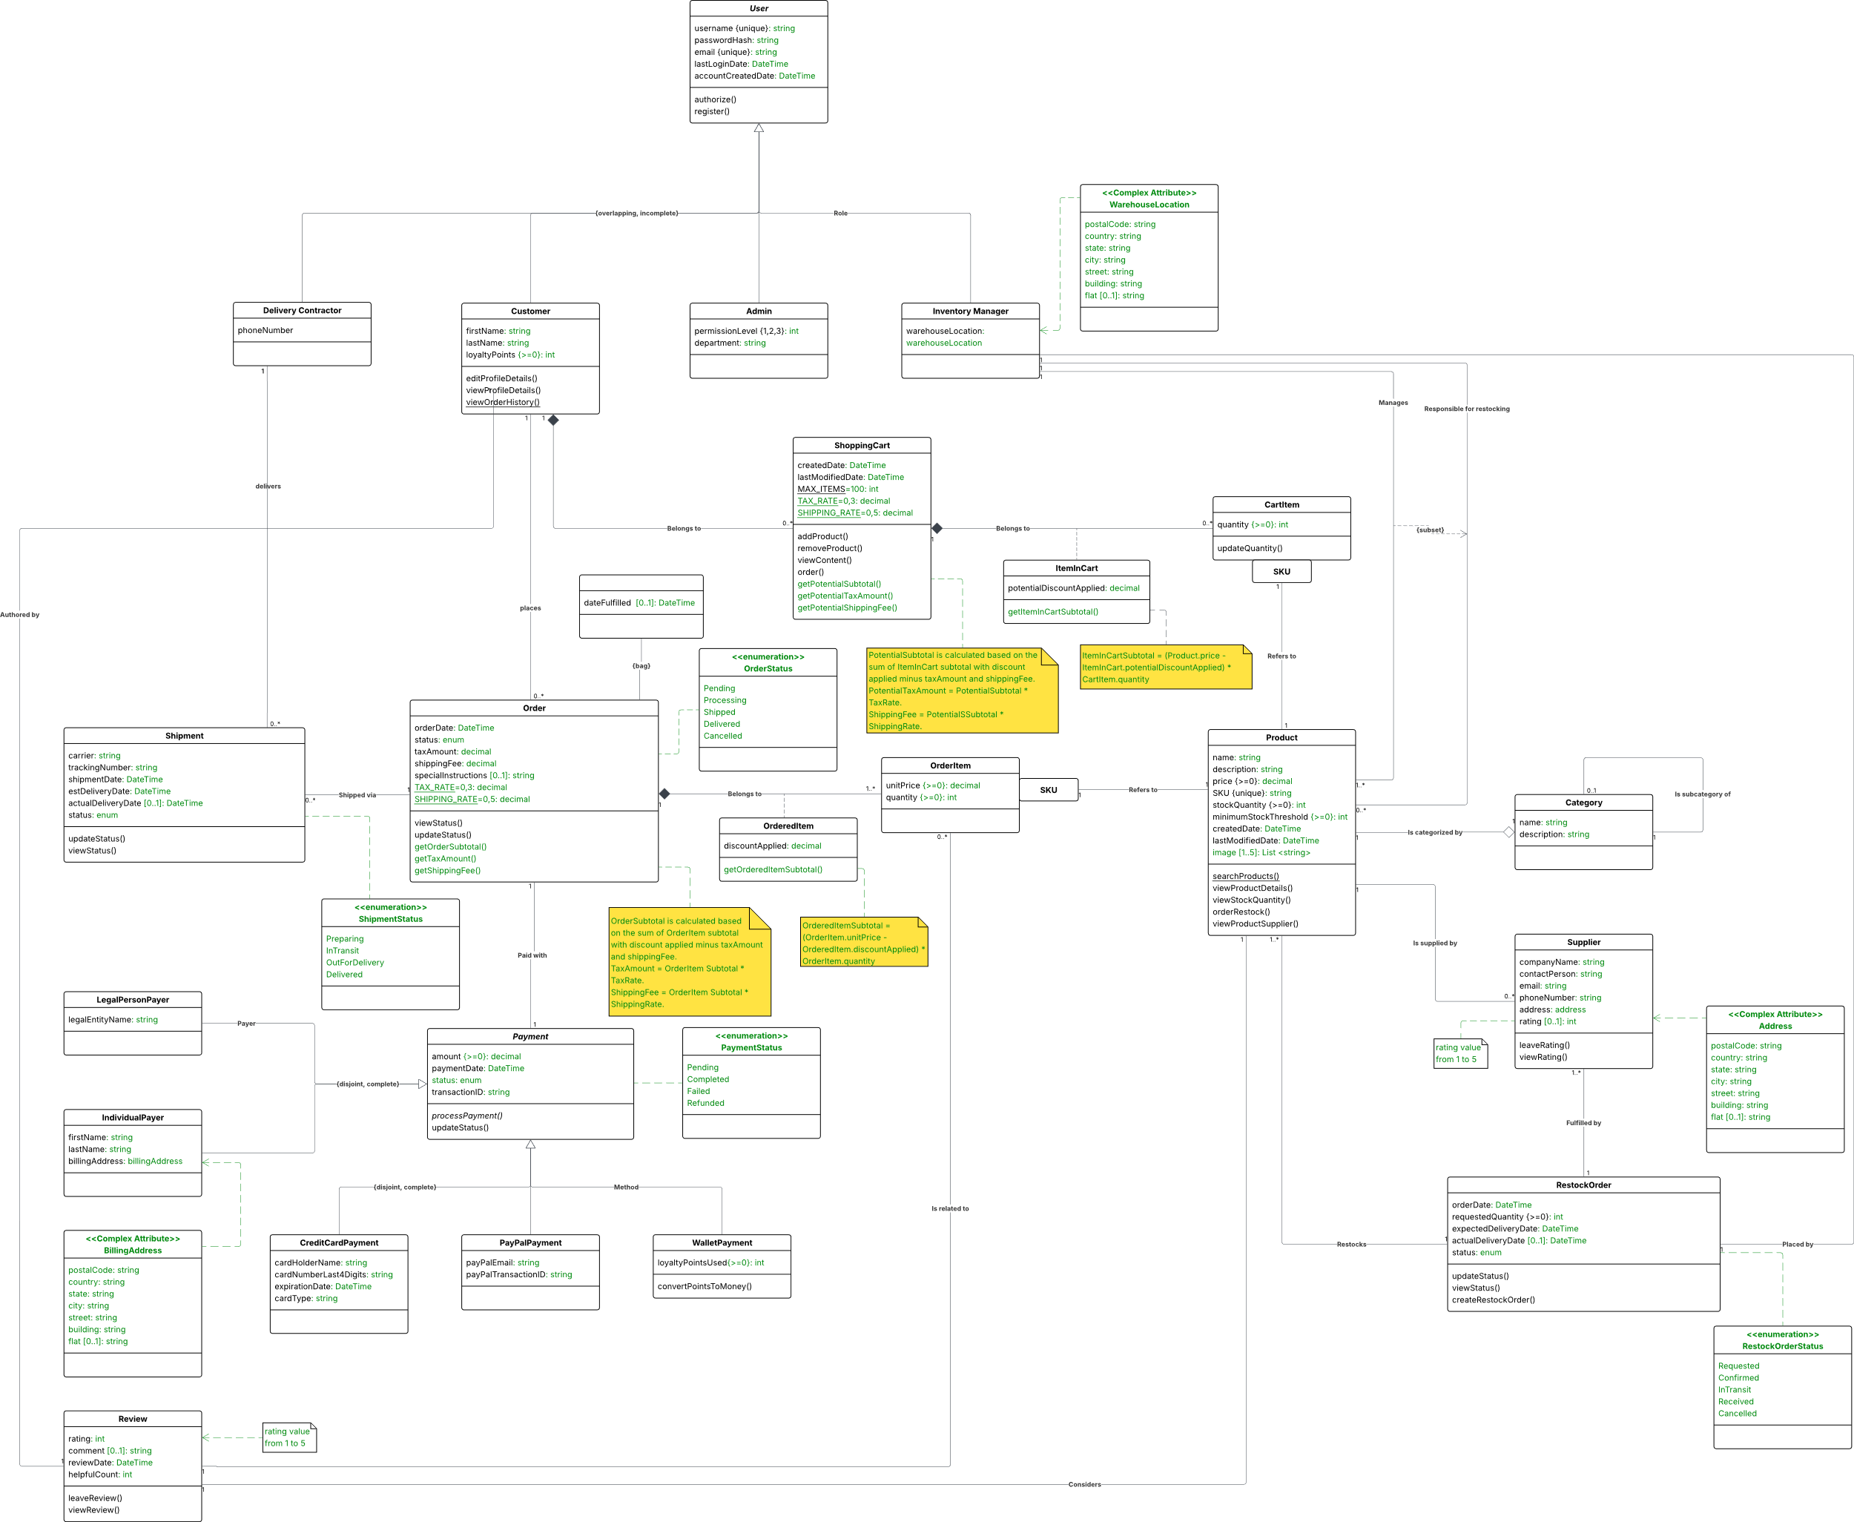
Design Description:
The design class diagram presents the types of class attributes of the E-Commerce System and reveals enumeration notations. The changes introduced are highlighted in green. The programming language – C#. The following section will describe the transformation process of certain UML constructs such as attributes types (based on the UML notations).
The attribute types shown in the design class diagram:
- basic (decimal, int, string, DateTime, etc.);
- complex (e.g. complex attribute “Address”);
- multi-value (e.g. the multi-value attribute “image” in the “Product” class has a defined range of 1 to 5 and uses string datatype);
- class (e.g. the class attribute “MAX_ITEMS=100” in “ShoppingCart” class describes that the maximum number of items a shopping cart can hold is 100);
- derived (e.g. derived attribute “/subtotal” in “Order” class is implemented as the “getOrderSubtotal()” method);
- optional (e.g. the optional attribute “rating [0..1]” in the “Supplier” class).
Enumerations are implemented for the next attributes:
- status, “Order” class (enumeration “OrderStatus”);
- status, “Shipment” class (enumeration “ShipmentStatus”);
- status, “Payment” class (enumeration “PaymentStatus”);
- status, “RestockOrder” class (enumeration “RestockOrderStatus”).

Attribute Validations
Attribute-level validation is implemented using Data Annotations in C#. These built-in annotations provide a declarative way to enforce data integrity rules directly on class properties, reducing manual validation code while ensuring consistent data quality across the system.
Optional Attributes
Optional attributes may contain no value (null) when information is unavailable or not applicable. They are implemented using nullable types in C# and are represented on the diagram with the multiplicity range [0..1].
Multi-value Attributes
Multi-value attributes store multiple related values within a single property. For example, the "image" attribute in “Product” class is a multi-value attribute which stores a collection of product images with constraints [1..5]. The constraint means:
- minimum 1 image: ensures every product has visual representation;
- maximum 5 images: prevents visual overload and maintains page performance.
Derived Attributes
Derived attributes are calculated properties that derive their value from other attributes. They are implemented as read-only properties in C# and automatically recompute their value when accessed. For example, the “subtotal” attribute (“OrderedItem” class) calculates the subtotal of ordered item, including potential discounts:
Subtotal { get => ( ( unitPrice– discountApplied) * quantity) }.
Class Attributes
Class attributes maintain a single shared value across all instances of a class. They are implemented as static properties in C# and are underlined in UML diagrams. For example, “MAX_ITEMS” attribute describes that the maximum capacity of a shopping cart for all users. In the UML diagram, class attributes are underlined.
Tagged values
Tagged values from the analytical diagram are implemented as enumerations in C#. They are used to describe some properties of class attributes and provide some extra properties. Each enumeration defines a fixed set of possible values that attributes can accept.
Complex Attributes
Complex attributes are implemented as separate classes. Complex attributes can be nested within other attributes when necessary, creating hierarchical data structures that mirror real-world complexity.

Design Diagram after Dynamic Analysis:
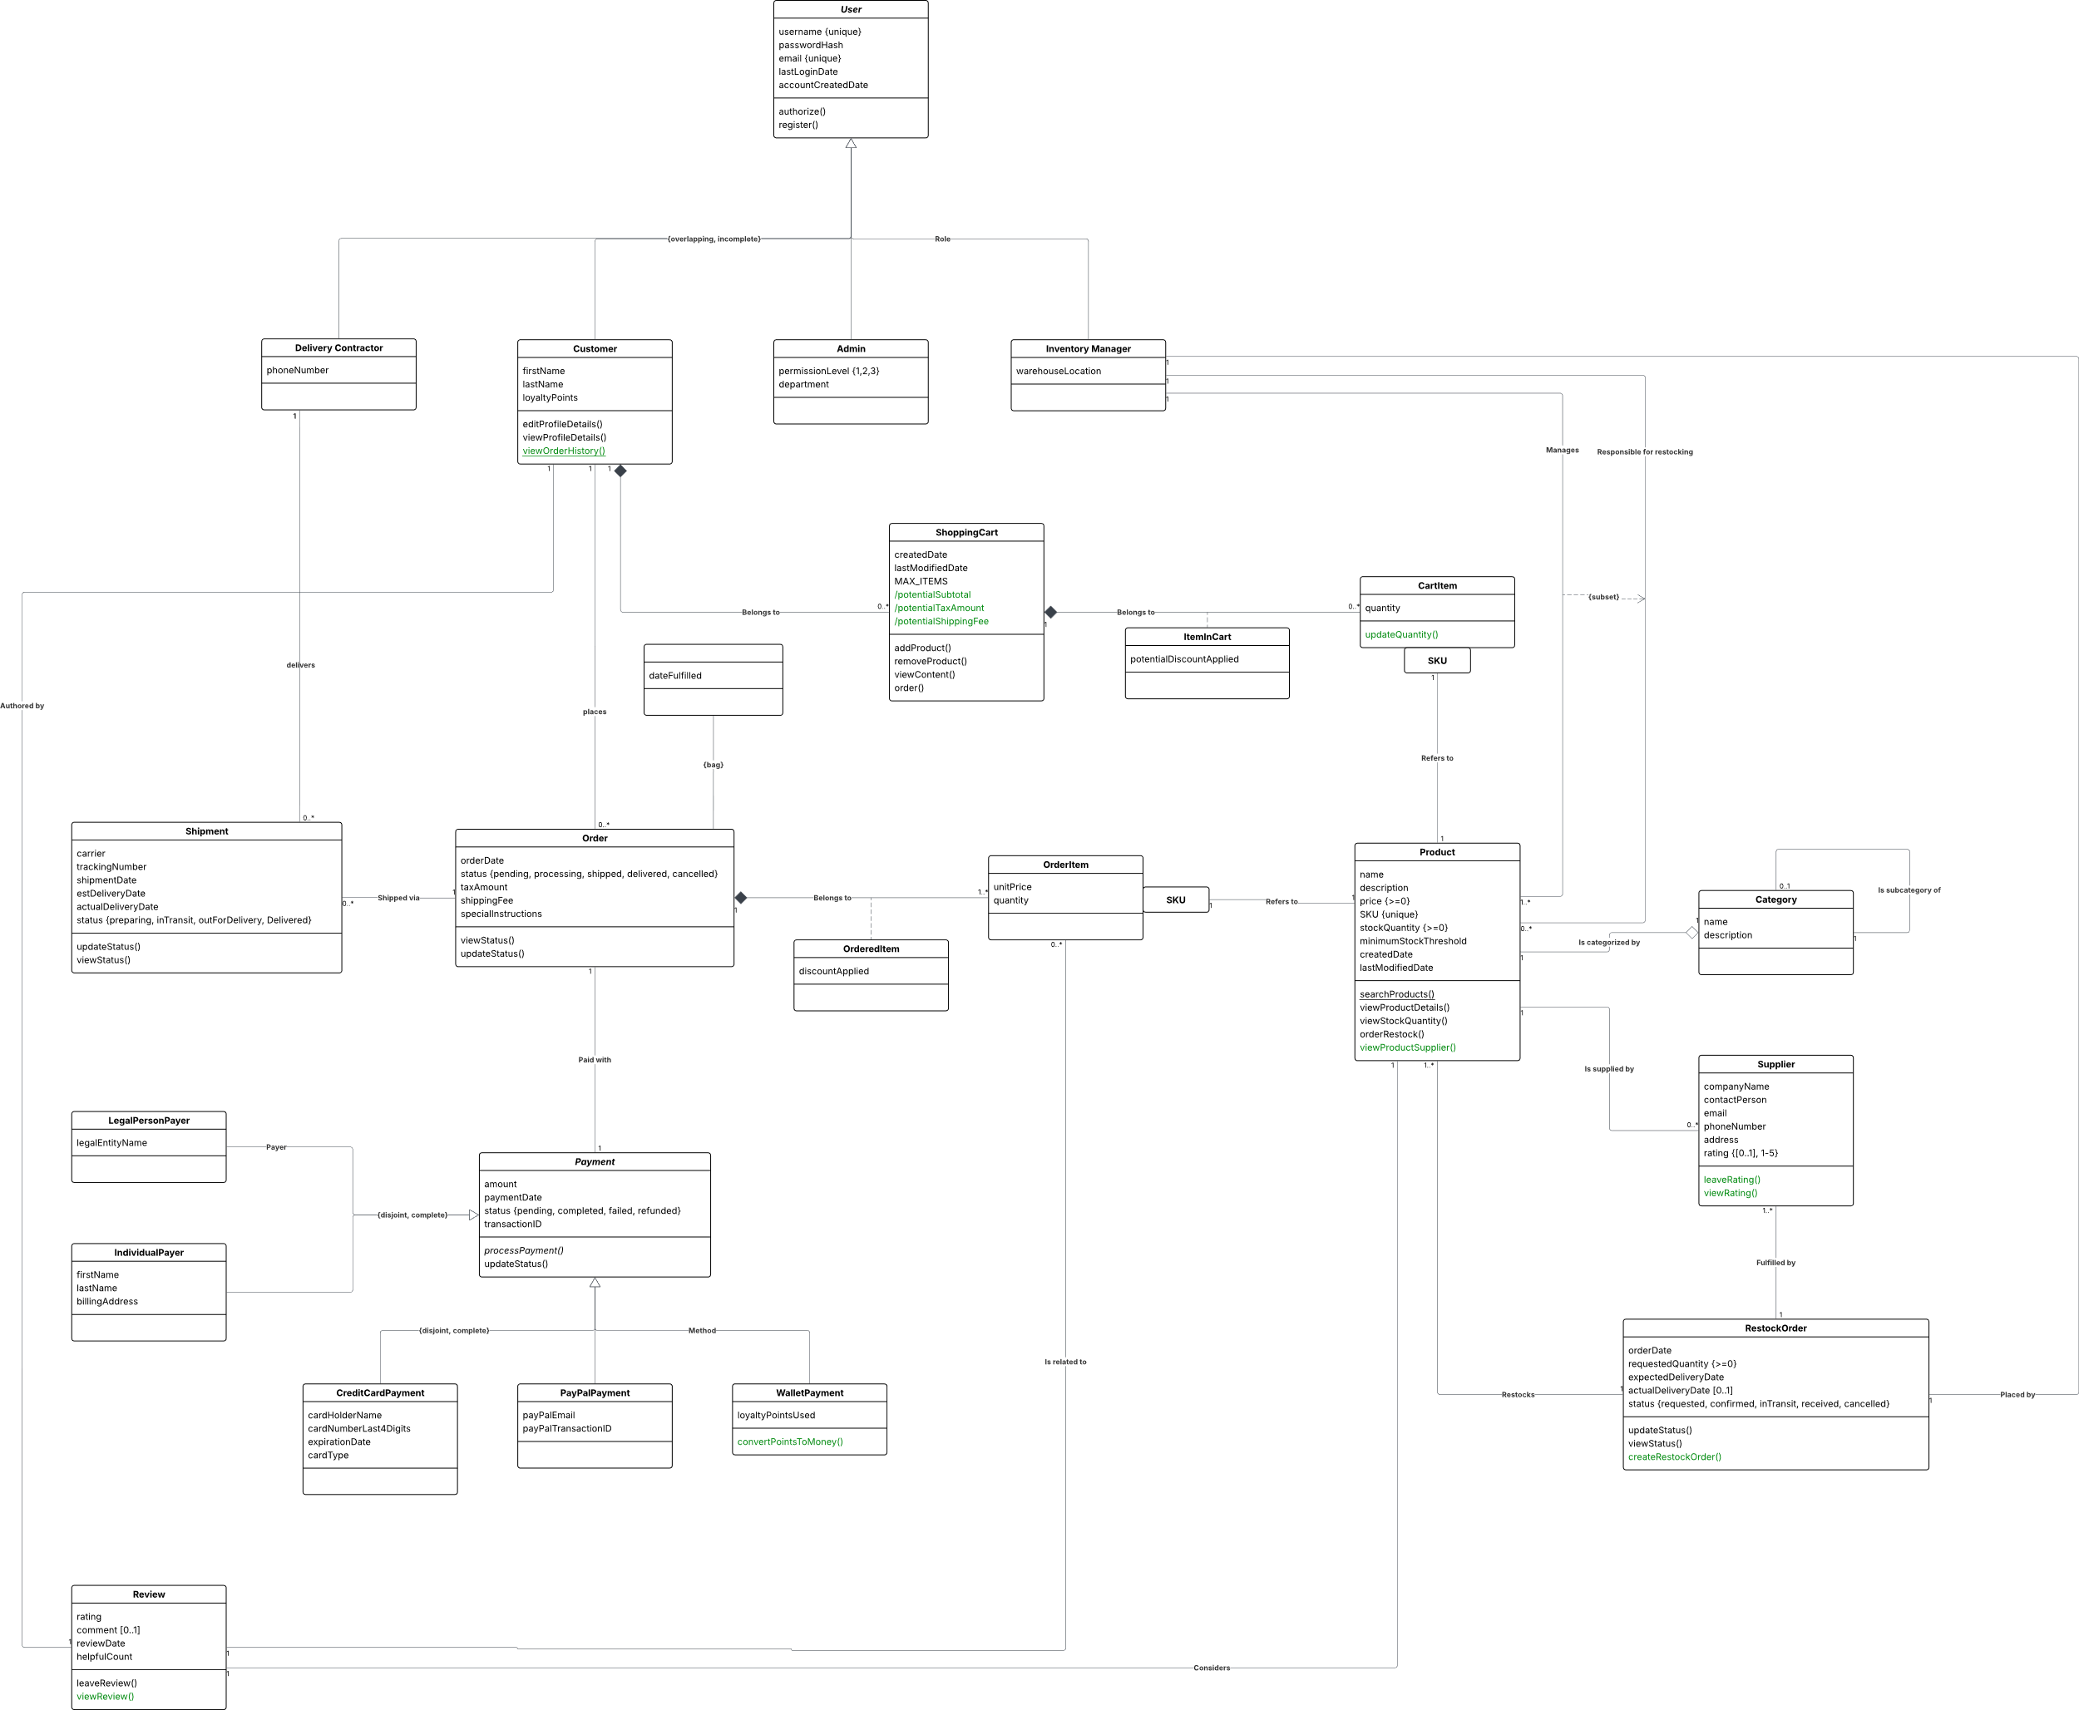
Dynamic Analysis Notes:
Following the presented diagrams, a dynamic analysis was performed. The result of this analysis indicated a need for further expansion on the design class diagram to encompass newly identified requirements and behaviors of the system. All introduced changes are highlighted in green.

  - Additions Related to the “Customer” Class
The “Customer” Class is a specialized subclass of User that demonstrates an end-user who can shop, place orders, earn loyalty points, and manage their profile.
- earnLoyaltyPoints() – This method was added to allow customers get loyalty points for their orders.
- applyLoyaltyPoints() – This method was added to allow customers to redeem earned loyalty points during finalizing order.

  - Additions Related to the “Product” Class
The “Product” Class represents an item available for sale in the e-commerce catalog.
- checkIfLowStock() – This method was added to evaluate if stock is at or below the minimum threshold.

  - Additions Related to the “ItemInCart” Class
The “IntemInClass” Class represents a single product entry within a customer’s shopping cart.
- applyPotentialDiscount() – This method was added to apply a discount to the specific cart item.

  - Additions Related to the “OrderedItem” Class
The “IntemInClass” Class represents a finalized product entry within a completed order.
- applyDiscount() – This method was added to apply a confirmed discount to the ordered item.

  - Additions Related to the “Payment” Class
The “Payment” Class represents a financial transaction within the e-commerce system.
- viewPaymentStatus() – This method was added to display the current payment status.

During the dynamic analysis of the class diagram, certain attributes were given new, clearer names to improve readability, align with naming conventions, and better reflect their purpose in the system (e.g. viewStatus() -> viewOrderStatus(), updateStatus() -> updateShipmentStatus()).

Assignment 6: Associations and Reverse Connections

This assignment implements bidirectional associations and introduces new association types to the e-commerce system.

Reverse Connections Implementation

The following associations were updated to support reverse connections:

1. Customer ↔ Order (bidirectional)
- Customer maintains a collection of Orders
- When Order is created, it automatically adds itself to Customer's collection
- Implemented methods: AddOrder(), RemoveOrder(), SetCustomer()

2. Supplier ↔ Product (bidirectional)
- Supplier maintains a collection of Products
- Product can reference an optional Supplier
- Implemented methods: AddProduct(), RemoveProduct(), SetSupplier()

New Class: Category

Category class was introduced to implement reflex and qualified associations:

Reflex Association:
- Category can reference a parent Category
- Category maintains a collection of subcategories
- Circular reference prevention implemented
- Example: Electronics → Computers → Laptops

Qualified Association:
- Category stores Products indexed by SKU (Dictionary<string, Product>)
- Fast O(1) product lookup by SKU
- Automatic update when Product SKU changes
- Implemented methods: AddProduct(), RemoveProduct(), GetProductBySku()

Association Types Summary

The system now implements all required association types:
1. Basic association: Order → Customer
2. Composition: ShoppingCart → ItemInCart
3. Aggregation: Product → Supplier
4. Reflex: Category → Category (parent/subcategories)
5. Qualified: Category → Product [by SKU]
6. Association with attribute: OrderedItem (between Order and Product)

Exception Handling

All associations include validation for:
- Null references (ArgumentNullException)
- Duplicate entries (InvalidOperationException)
- Circular references in Category hierarchy
- Referential integrity on both sides of bidirectional associations

